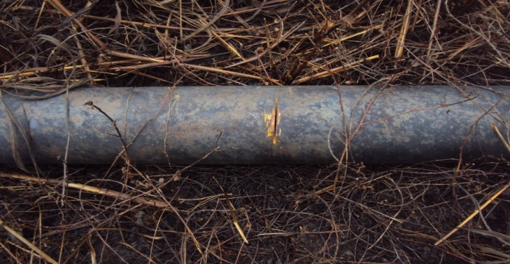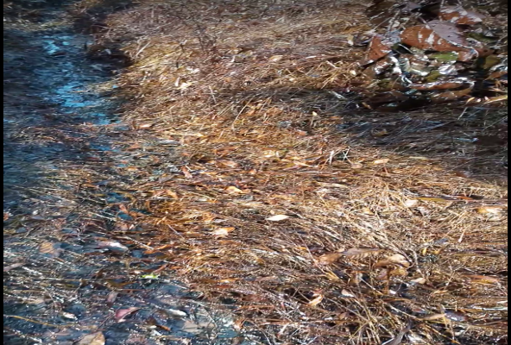
Figure 1. The spill point showing hacksaw cut Figure 2. Showing Impacted Area

